Spectorandco Virtual flyer designer user guide

URL: http://172.16.10.236/virtual_design/virtualFlyerDesigner.php
- Terms:
Template: flyer page background image (A4 size,300DPI)
Virtual product: spectorandco item with decorated artwork.
Flyer page: single flyer page which contains virtual products, text and graphics.
- Templates management
You can add/delete your templates in the tab: Templates
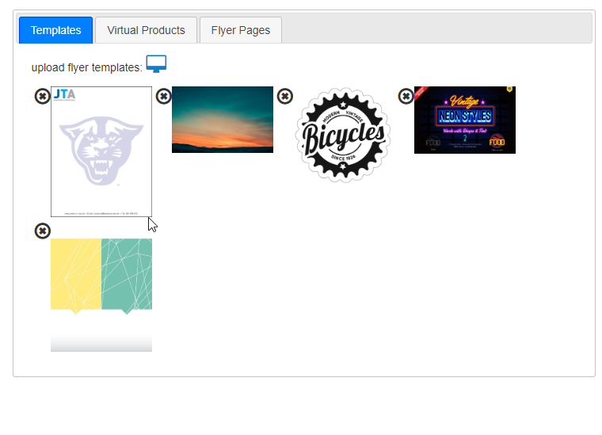Add template: click on icon “computer” to add template from your local computer.
Delete template: click on icon “.
- Design virtual product
Click on tab “Virtual Product”, you will see as following:
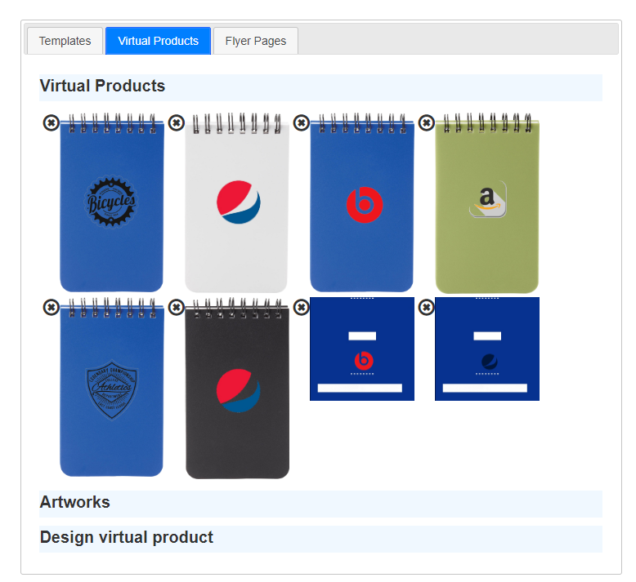
- Delete designed virtual product:
Click on icon (), it will delete the virtual product.
- Design new virtual product
Step 1: Click on “Design virtual product”, it will show the following:
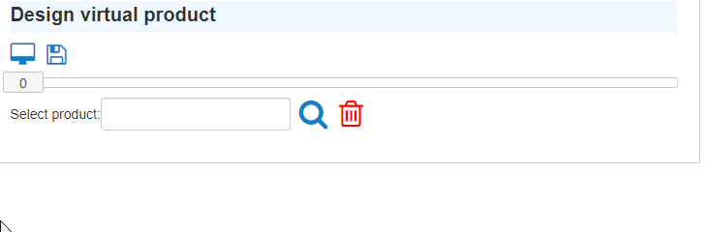
Step 2: input product item code, click on “search” icon, it will show colors of item, price and decoration methods:
Step 3: choose decoration method.
Step 4: choose color.
Step 5: click on the selected color image.
Step 6: add artwork.
You can choose artwork from available artworks, click on “Artworks”, it will show all available artworks, click on the artwork you want. Other way, you can load artwork from your computer, click on icon computer:
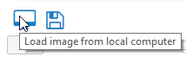
And choose your artwork.
When start to add artwork, one animation will display to show its working. When animation is gone, artwork will show on the item image. You can resize/rotate/relocated artwork.
Step 7: save virtual product, click on icon “disk”.
After save action is done, virtual product will show on the list of virtual products

- Design flyer page (Tab: Flyer Pages)
On this tab, you will available flyer templates, available virtual products and available flyer pages.
- Design new flyer page:
Step 1(Optional): choose flyer template
Step 2: choose virtual products.
Step 3: add Text/graphics
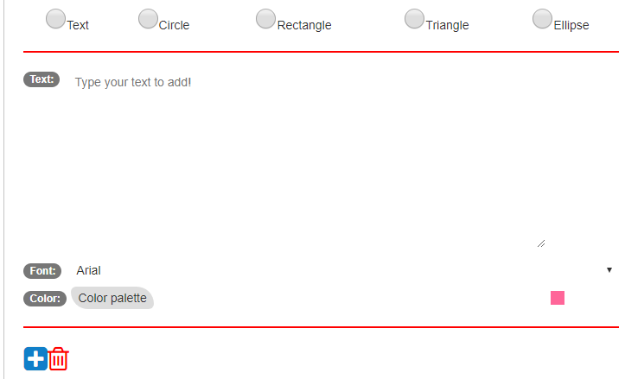
Step 4: save flyer page, click on icon

- Modify existed flyer page:
Step 1: click on flyer page which you want to modify, it will show on the screen.
Step 2: click on virtual product/text/graphics, then modify it.
Step 3: save your modification, click on
- Generate flyer and download
Select flyer pages which you want to put in the flyer and click PDF icon, it will generate flyer pdf file and show “download PDF” button. Click on this button, the flyer pdf will be downloaded to your computer.

