Spector&Co Virtual Product Parameters Handle Process User Guide
- Download product image from Spector&Co website color by color.
For example: B104-blue
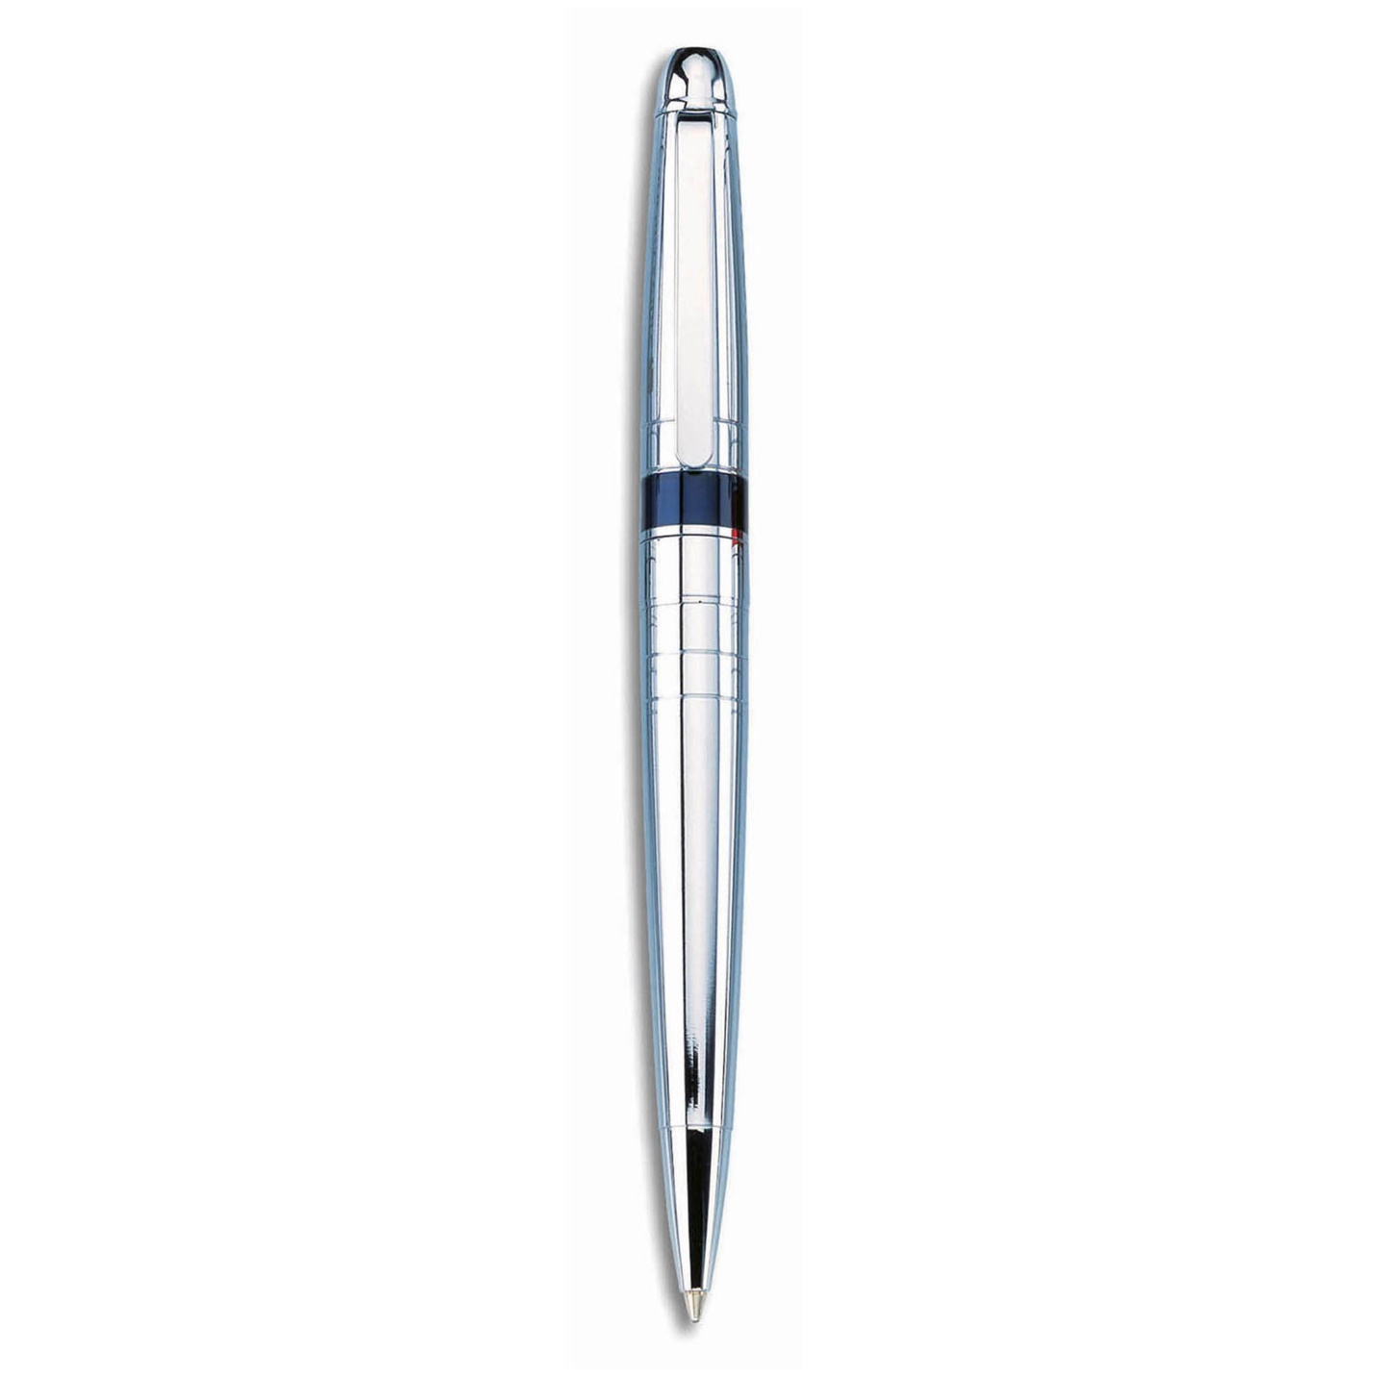
- Rotate the product image
This step is optional, it depends on product. For B104, it needs to be rotated.
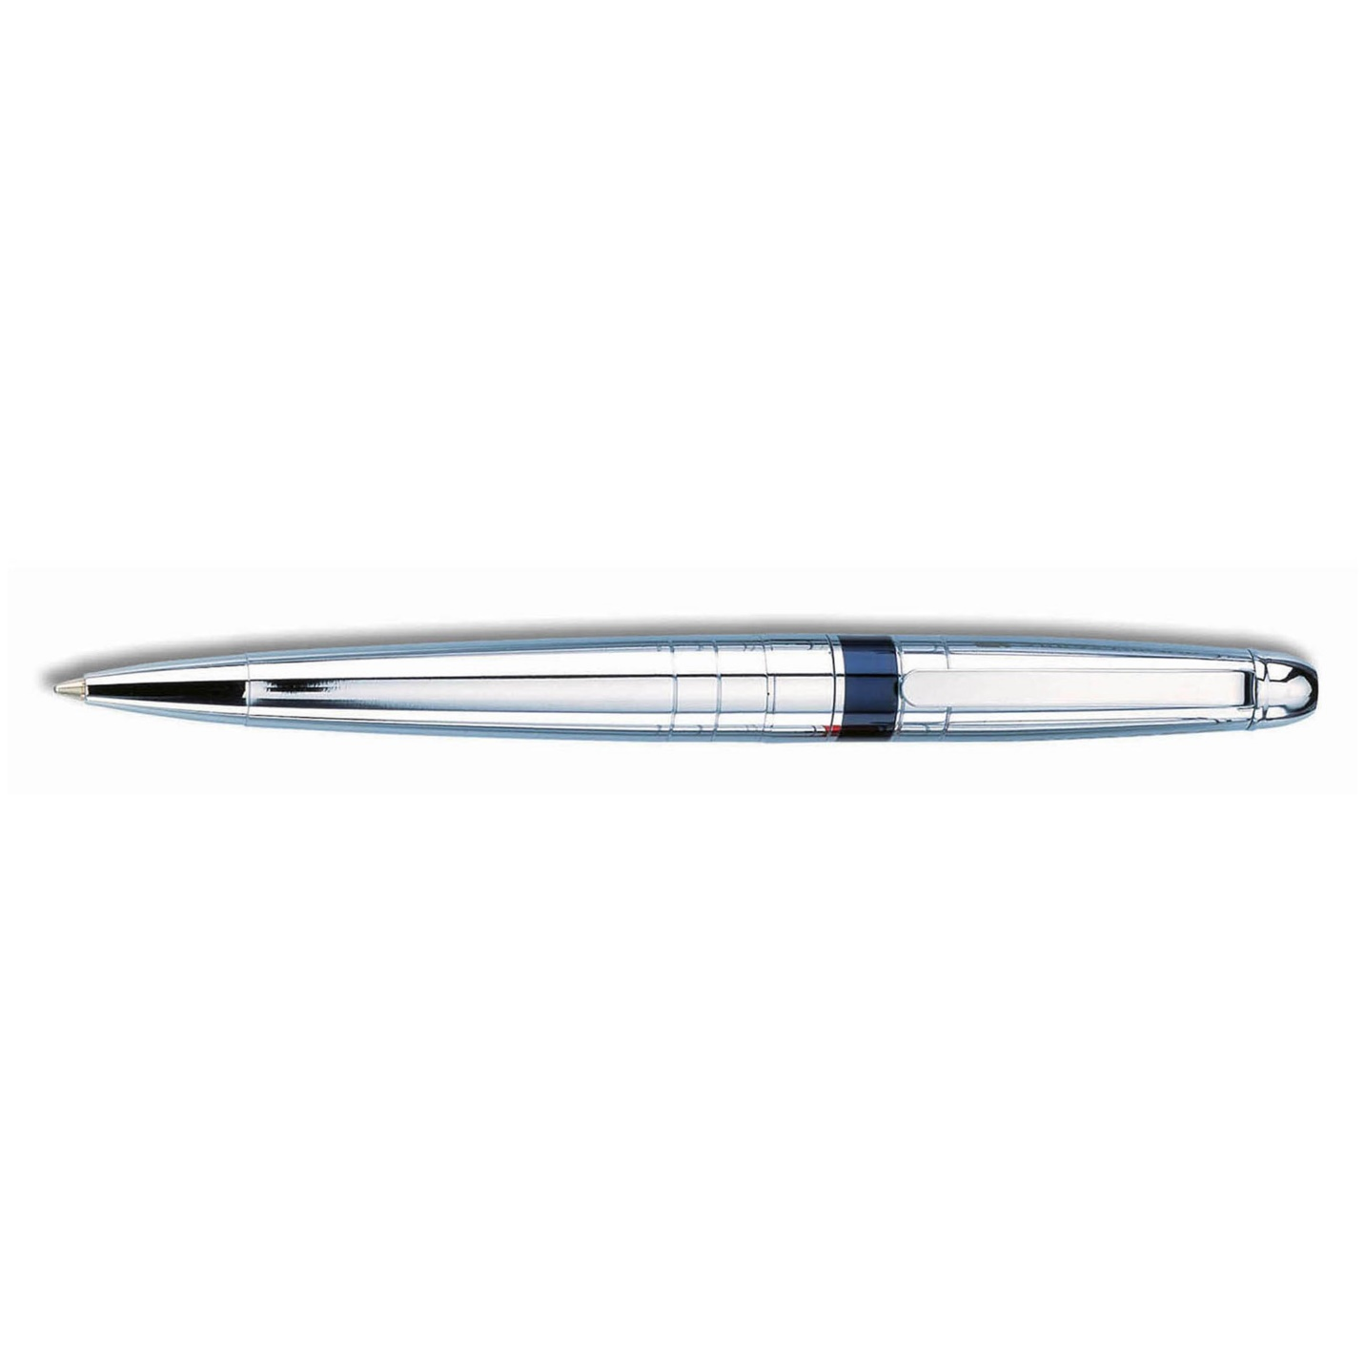
- Remove unnecessary background, let image only cover product.
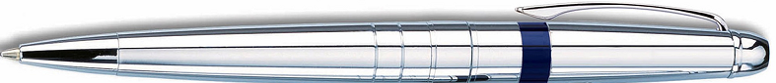
- Measure start point and calculate draw area of decorating method:
For example: Decorating method: Laser Engraved
- Start point: Beside clip
Measure start point: (566, 37)
- Calculate draw area—Width and Height
Step1: find out width of image, and height of image (unit is pixel)
Step2: find out width of product, and height of product (unit is inch)
Step3: calculate pixels in 1 inch for image (call it PI)
Step4: width of draw area on image = width of draw area * PI;
Step5: Height of draw area on image = height of draw area * PI;
- Add image and draw area parameters to master database
Open chrome browser, and type the following url to launch spector&co virtual product parameter management tools:
http://209.104.80.75/spectorco_virtualdesign/spectorcoVirtualProductParametersManager.php, you will see the following screen
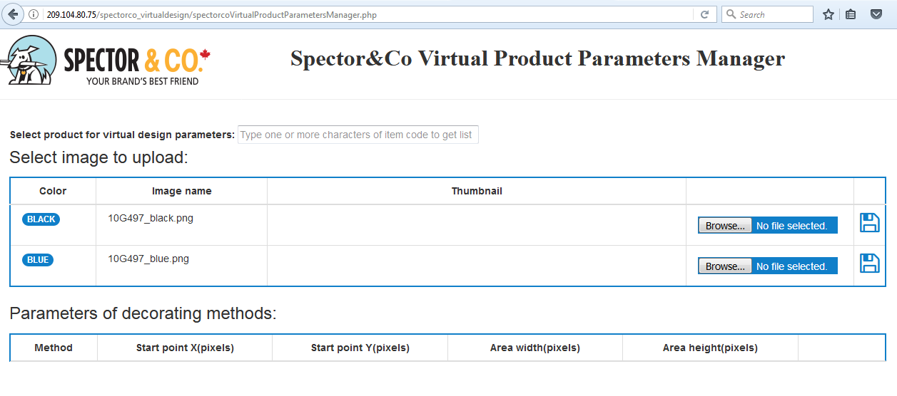
6 Select product item code and load panel of upload image and add parameters of decorating method:
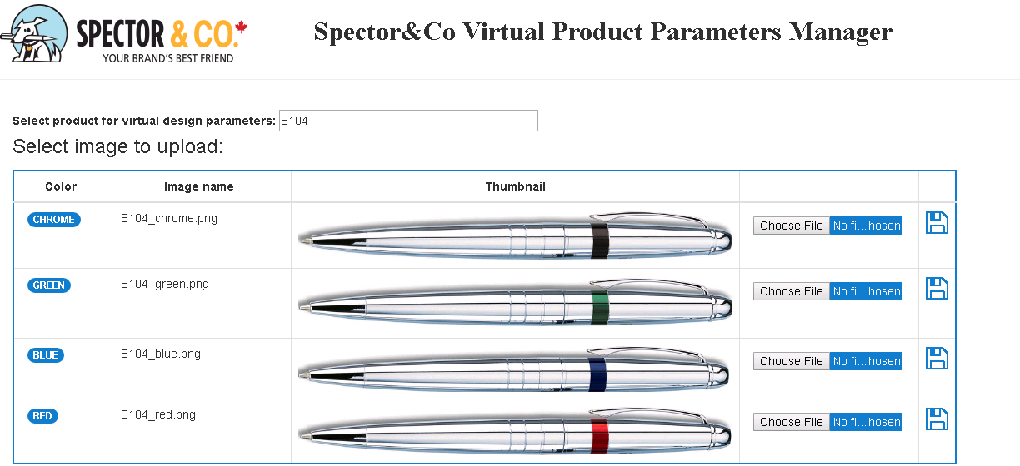
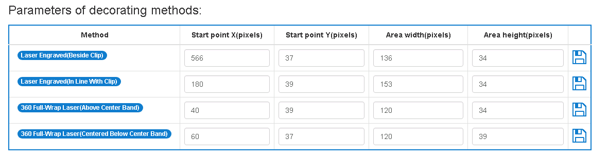
  - Upload image: click on “choose File”, select image, click on to upload image to web server. If upload success, Thumbnail of image will display.
  - Add parameters of decorating methods:
Input start point x (pixels)
Input start point y (pixels)
Input area width (pixels)
Input area height (pixels)
Click on to save into master database.
  - Check parameter of decorating method:
Click on method span, for example,, the popup window will show printing area as following:
